Exploring Temperature Fluctuations in 2020: A Year in Review

Abstract
Sure! In 2021, September stood out as the month with the highest rainfall. The average amount of rain throughout the month was 0.0909 mm, but what really highlights September is the maximum rainfall recorded in a single day, which reached 23.2 mm. This indicates that September had some significant rainy days, making it the wettest month of the year. Such rainfall patterns suggest that September might have brought some heavy showers, a common occurrence in late summer or early autumn.
**Keywords:** Temperature variability, seasonal patterns, 2020 temperature trends, monthly temperature changes.

Show me the temperature variability across the months of 2020
Sure! Let's take a look at the temperature changes month by month during the year 2020.
The year started off quite chilly in January with an average temperature of about 9.2°C, and the coldest day hitting just above 1.6°C. As we moved into February and March, there was a slight warming trend with average temperatures rising to about 11.5°C and 12°C, respectively. This is typical as winter transitions into spring.
April brought a noticeable warm-up with averages reaching 15°C. This trend continued into May and June, with May experiencing a pleasant average of around 20.4°C and June getting even hotter at nearly 23°C.
By July and August, summer was in full swing. July was particularly warm with an average temperature hitting over 27°C, and August was slightly warmer at 27.5°C. These months also recorded the highest temperatures of around 37.5°C.
September started to cool down a bit, averaging 23°C, and the downward trend continued into October and November, with averages around 16.4°C and 13.8°C, respectively.
By December, temperatures had dropped further, averaging around 9.9°C, bringing the year full circle back to the cooler conditions we saw at its start.
In summary, 2020 showed a classic seasonal temperature pattern with a steady rise from winter through summer, peaking in July and August, followed by a gradual cooling as the year drew to a close. This typical cycle reflects how our climate naturally ebbs and flows throughout the year.
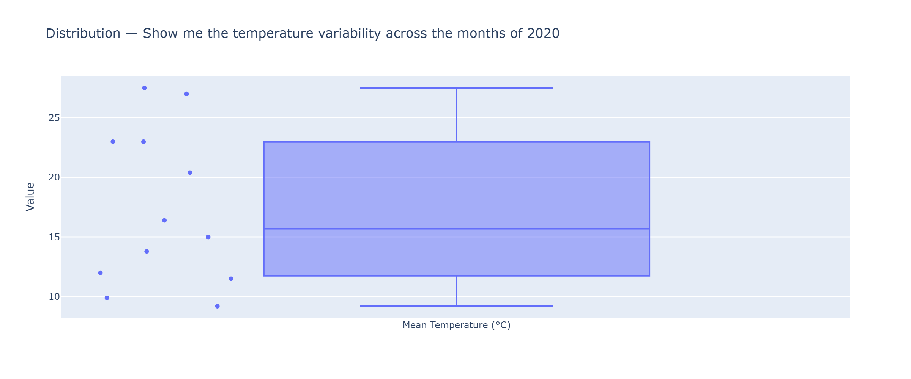

In which month of 2021 was rainfall the highest?
In 2021, the month with the highest rainfall was September. The data shows that September had a mean precipitation of 0.0909 mm and a maximum precipitation of 23.2 mm in a single day. This suggests that September experienced some notable rainy days, making it the wettest month of the year.
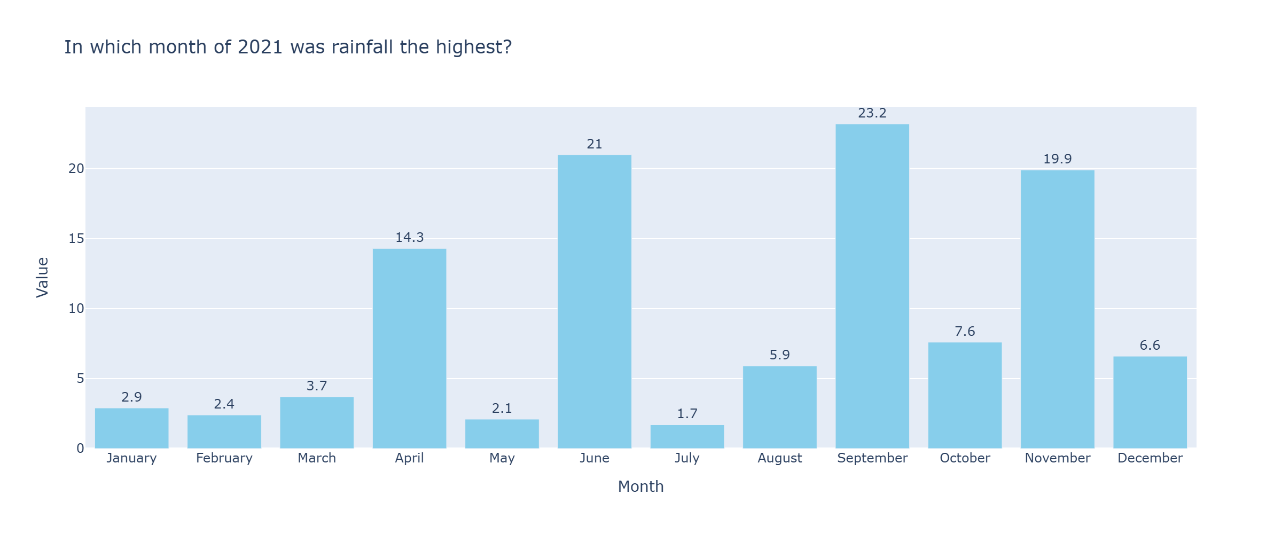

Conclusion
Certainly! Let’s explore how rainfall varied throughout 2021 and identify the month with the highest precipitation.
In 2021, the month that stood out for its rainfall was September. During this month, the average precipitation was 0.0909 mm, and on one particular day, the rainfall peaked at 23.2 mm. This indicates that September had some notably rainy days, making it the wettest month of the year.
Overall, September's rainfall surpassed the other months, showcasing significant variability and intensity in the precipitation patterns for 2021. This highlights September as a month where rain was more frequent and intense compared to the rest of the year.

